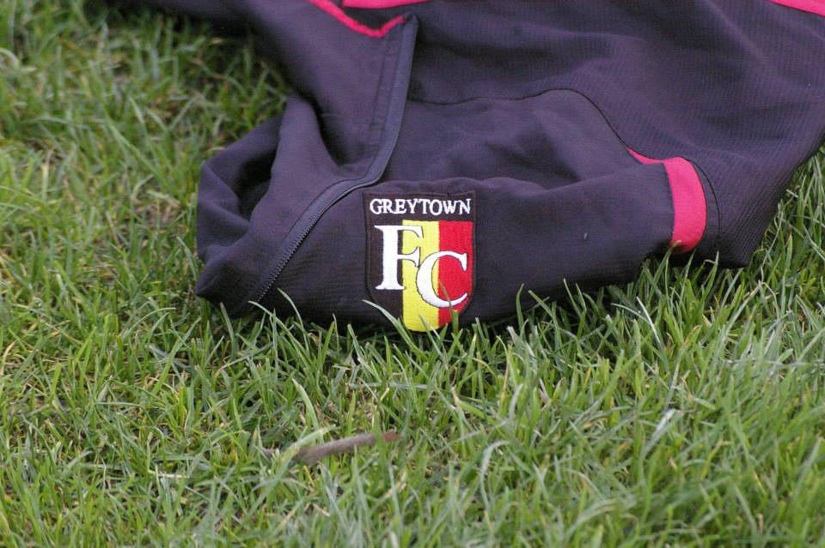

Annual Report   
2013

Website

Executive Introduction

Greytown Football Club was established in 2009 to offer the community of Greytown and the people of the South Wairarapa an opportunity to play and learn football in a supportive environment.   
  
In its first five years it has grown to over 50 members, across three teams with a growing supporters group. Player’s ages range from 15 to 55. The club has great support from Greytown Sports and Leisure Society, Greytown Junior Football Club, Kuranui College and Capital Football.

Our committee is made up of people who are passionate about Football and bring a wide range of skills to support the club.

Football is a popular sport within Greytown with 13 teams in the junior grade, 4 teams at college and 3 senior teams. Players from all over the Wairarapa see value in our club and travel to play under the Greytown banner.

The club has received many awards and trophies over its existent. The White Swan Team won the league championship in 2012 which saw promotion into the Wellington Capital 3. The biggest achievement from the club has been being awarded Club of the Year in 2010, 2011 and 2012. The club is an all-inclusive club and looks to support all levels of players and supports alike.

Mission

To provide opportunities for people of all ages and ability levels within the District to improve their quality of life through participating in or playing the game of football.

Vision

To provide a football club, based in Greytown, which supports  
football players of all ages.

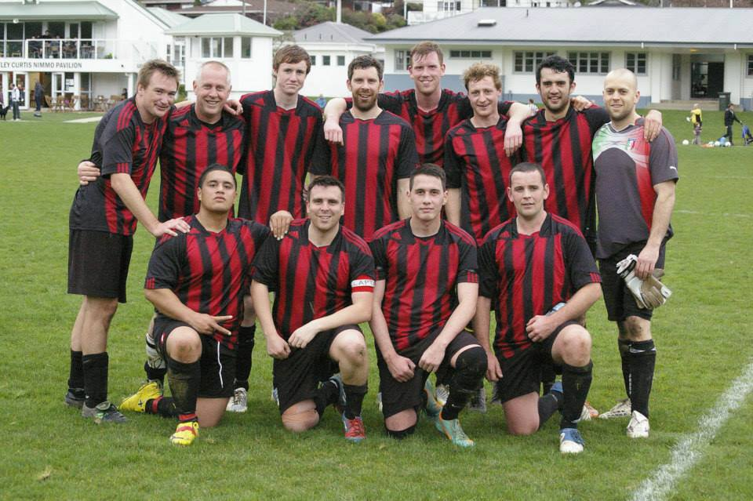

Club Objectives

The Greytown football club at the beginning on 2013 reviewed and set its strategic plan for 2013-2016 this involved identifying some key club objectives which were translated into a yearly plan for 2013. The purpose of the club objectives is to keep our minds and actions related to the management of the club, on the bigger picture. The club objectives are listed below:

1. **To promote, organise, foster, develop and play the game of amateur football.**
2. **To maximise the potential of players, coaches, managers, officials and administrators by promoting commitment and skill development at all levels**
3. **To encourage fair play and respect**
4. **To promote the fun and social aspect of the sport**
5. **To promote the involvement of family and the wider community**
6. **To support and form allegiance with the Greytown junior football club and Kuranui College through practical and technical assistance**
7. **To maintain a close liaison with Capital Football (No 5 District Federation of New Zealand Soccer Incorporated) or such other body controlling football in the Wellington Region and to adhere to and observe the objects and rules**

A brief summary of how the GFC activities for 2013 have aligned to these objectives are listed on the following page

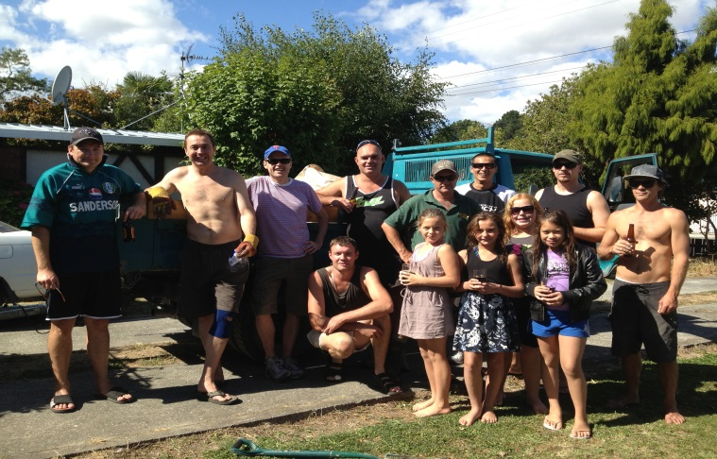

Club Objectives - Continued

**To promote, organise, foster, develop and play the game of amateur football.**

The Club continued its growth for 2013 with all three teams fully locked in with an abundance of players. The Club considered entering a four team into the local competition however it was decided to postpone that option until 2014. The clubs reputation has continued to grow and our brand is well received by all within the community. This was well represented by the achievement of four sponsorship arrangements being established.

Promotion of the game and the GFC has been through wide ranging methods of communication. Our Facebook page has continued to grow with 173 likes which is an increase of around 15%. Communications and club updates have been provided through the Greytown Grapevine , other mechanisms used were through the Greytown Community Sports and Leisure society (GCSL) newsletter and media.

A wide ranging amount of photographs (approximately 2500) were taken throughout the year of all teams. This was endorsed and appreciated by all opposition teams and supporters through comments. They were all posted to the Facebook page.

**To maximise the potential of players, coaches, managers,   
officials and administrators by promoting commitment and skill development at all levels**

The provision of three teams enabled the players to participate at a level appropriate to their ability and provided more game time for all players.

Although with player numbers this did present some unexpected challenges that were well managed by the team managers and coaches.

Training and seminars were offered to players and committee members where appropriate. Information from the GCSL and Capital Football assisted us in providing these offerings.

Training sessions were well attended for most of the season. With   
the White Swan team having very structured trainings on Thursday   
nights and a club training was provided on Wednesday nights.

Committee numbers were strong and two members of the club were elected to the GCSL board.

**To encourage fair play and respect**

All members of the club were communicated to on the expectations of the committee. To ensure they continued to meet those expectations, this was delegated to team management and was continually monitored.

There was an increase in the amount of yellow cards received for 2013. Further analysis of this indicated that with the White Swan team moving into a more competitive league that the standard of refereeing increased. This was addressed mid-season which saw a reduction in the amount of cards received over the latter half of the season. However none of the cards received were for dissent or violent conduct.

The GFC will be looking to further expand on its encouragement of fair play and respect for the 2014 season.

**To promote the fun and social aspect of the sport**

A part of each team management role was to create a culture appropriate to their teams. This was hugely achieved within all teams, which saw a marked increase in socialising after the game and through the attendance at the end of year prize giving.

All teams supported each other throughout the season, with the White Swan team being the draw card game. This saw an increased level of support both internal and external to the club.

The GFC maintained our high standard of being a great host to other clubs and we received strong feedback from the visiting teams from Wellington to further endorse our brand.

**To promote the involvement of family and the wider community**

All partners and family members were actively encouraged to attend games and after match functions. A key policy is ensuring the children are treated well and the facilities are appropriate (free chippies and chocolate). Two picnic tables, couches and additional outdoor seating was provided.

Communications via the junior and college committees as well as  
the GCSL newsletter, Facebook and the Greytown grapevine was   
utilised to promote key games and to further encourage community engagement.

The club also acknowledged key supporters at our 2013 prize giving through a team award and also the supporter of the year trophy. All partners were invited to attend the prize giving also.

**To support and form allegiance with the Greytown junior football club and Kuranui College through practical and technical assistance**

The GFC continues to build upon and maintain the close relationships with the junior football club as well as the college committee. A committee member was present at all meetings. The club president is also a junior committee member and reported back to the committee on areas of concern and updates. The Secretary is the representative on the college committee and also coaches one of the teams.

On-going assistance and training has occurred at junior and college level with many players coaching teams.

**To maintain a close liaison with Capital Football (No 5 District Federation of New Zealand Soccer Incorporated) or such other body controlling football in the Wellington Region and to adhere to and observe the objects and rules**

Greytown Football Club has established a great working relationship with capital football. The club has nominated two individuals to join the advisory boards for men’s and women’s football within the wider region.

The Club hosted a Capital Football meeting between all the local based clubs.

The Club also applied to Capital Football to assist in the funding of some new goal posts for 2014 and we were successful with a $1000 contribution.

The Club maintains in regular contact with Capital Football and receives all communications.

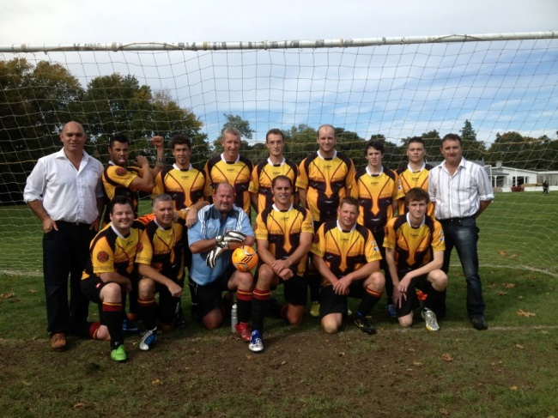

**Other Achievements**

The Club entered a team into the Wellington Capital Football Leagues for a first time in its history. This was to create a strong pathway for younger members of the Greytown community to further their footballing development. The team preformed exceptionally well for its inaugural year placing 6th overall and avoiding relegation comfortably. It was notable that the team only lost one game at home all season.

The local based teams performed well above expectations. The Turkey Red Division 2 team won their division for the first time and qualified for the knockout plate semi-finals. They were the only team to return silverware for the 2013 season.

The A1 homes (Spartans) team performed well, they finished mid-table in the Division 1 grade which was a step up for them from previous seasons. A key highlight was there semi-final win in the knock out cup against Douglas Villa Telecom Hub (he were top qualifiers). They performed well in the final but were unfortunate to not bring the cup home.

A significant milestone this year has been our relationship with City Care and the South Wairarapa Council on looking at areas of the management of the grounds and buildings and working through appropriate solutions. We look forward to finalising these arrangements for 2014

The club has succeeded on/off the field with numerous successful grant applications and a strengthening financial position. The club continues to support other local based clubs and will continue to look at mutually beneficial relationships moving forward.

**Our club awards:**

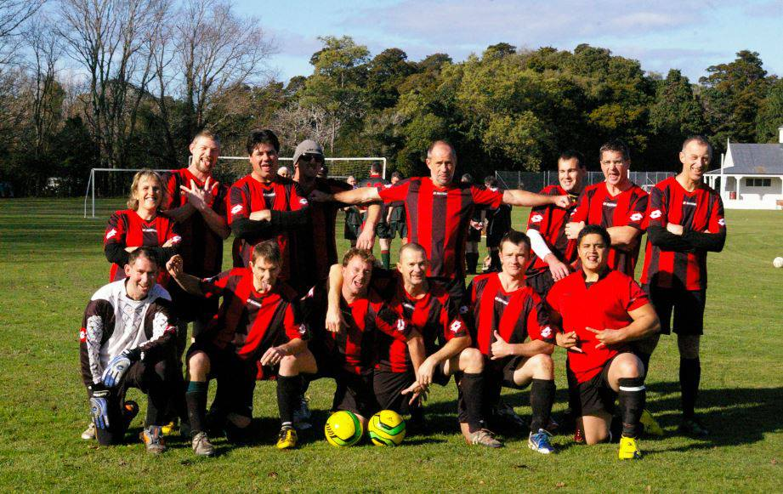

Wairarapa Division 2 champions

|  |  |  |  |
| --- | --- | --- | --- |
| **Strategic Goals** | **Strategic Initiatives** | **Key Performance Indicators** | **Outcomes** |
| Improve long term viability of the club | * Establish sponsorship agreements * Maintain college and junior connections * Develop a regular fundraising opportunity * Maintain grant applications * Support promising young players * Work towards developing a Swan reserve team | 1. 3 written agreements establish 2. Positive feedback from college and junior committee 3. $1000 raised by a method that could be continued 4. 4 applications applied for 5. 4 players under 18 are supported | 1. Sponsorship arrangements were set in place and documented. Four agreements are in place with one locked in for 2014. 2. All committee meetings have been attended and feedback provided to the Senior committee 3. $1540 was raised through firewood fundraising 4. Six grant applications were applied for (at four trusts). Four were successful, the two unsuccessful grants were then reapplied for and successful on the second attempt. 5. Approximately 6 players under the age were supported in their development. 3 within the first team, 1 in the seconds and 2 within the third team. |

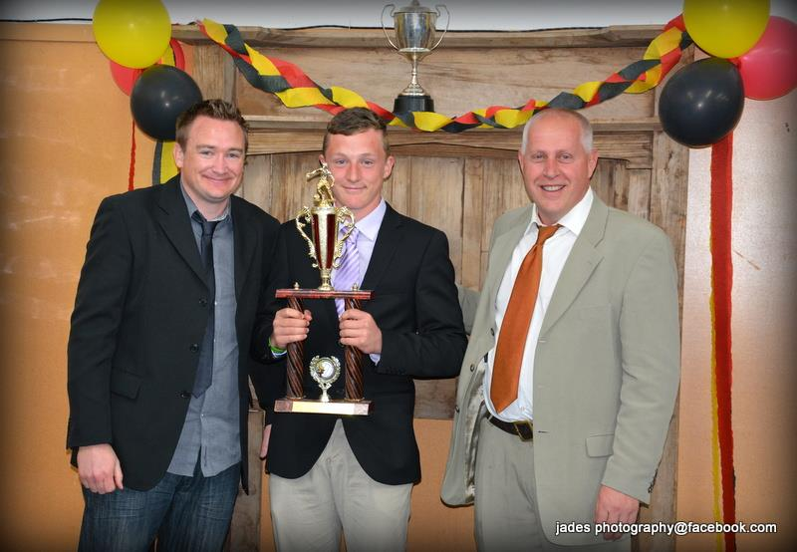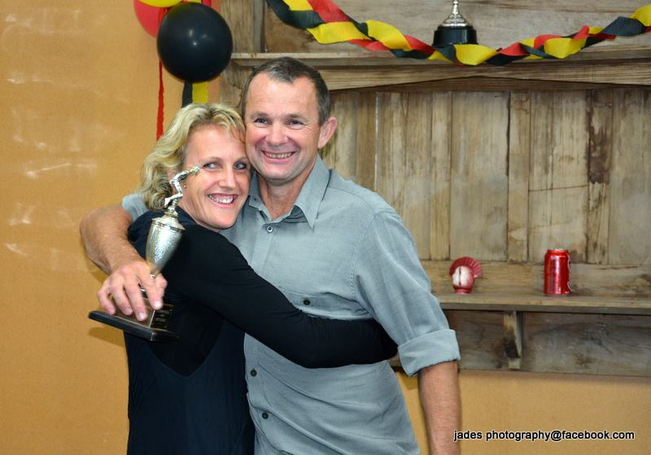

|  |  |  |  |
| --- | --- | --- | --- |
| **Strategic Goals** | **Strategic Initiatives** | **Key Performance Indicators** | **Outcomes** |
| Maximise player potential | * Ensure all teams suitably resourced with equipment and strip * Maintain a suitable training venue and support coaching initiatives * Provide opportunities for every level of play * Involved experts from outside the club | 1. All teams have a smart strip and a full set of team equipment 2. Lights put up for grass training, coach has all required training equipment 3. 3 teams – capital, first division and second division are supported 4. 2 experts are utilised | 1. All teams were provided with appropriate strip and equipment. This was maintained at a high level. 2. The floodlight project was completed and used for training nights for all teams 3. All teams were provided with support and guidance from the committee. 4. External experts were utilised in running training sessions for the White Swan team this involved senior players from Wairarapa united to assist. |



|  |  |  |  |
| --- | --- | --- | --- |
| **Strategic Goals** | **Strategic Initiatives** | **Key Performance Indicators** | **Outcomes** |
| Raise community profile | * Club activities * Combined activities with other community, sports groups * Develop professional image * Facebook ,Grapevine, website and Newspaper | 1. At least one activity involving the public is held 2. At least one event with another community group is held 3. Established dress code used by the Swan team, club signage and history 4. FB membership increased, 6 Grapevine articles, 2 Newspaper articles. | 1. Public invites were communicated throughout the season via the grapevine 2. The football club assisted the cricket club on their club day reunion. A preseason gathering was planned but had to be cancelled between the Rugby Club and Net ball club due to lack of numbers. Training sessions were run for the netball club to assist in pre-season fitness 3. The Swan team had a set dress code. Each player contributed to the costs of Vests. Many comments were received on how well the team looked. 4. FB Membership has increased by 15%, 5 grapevine articles have been written and 1 newspaper article. |

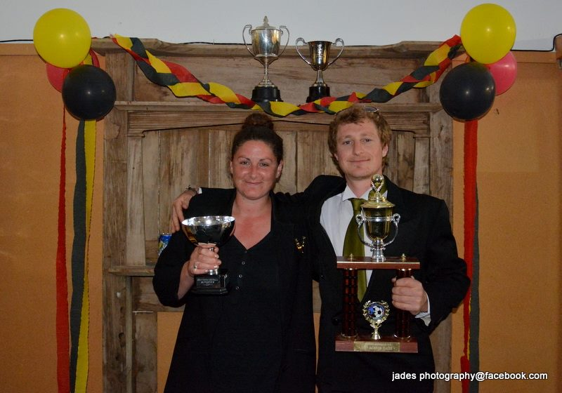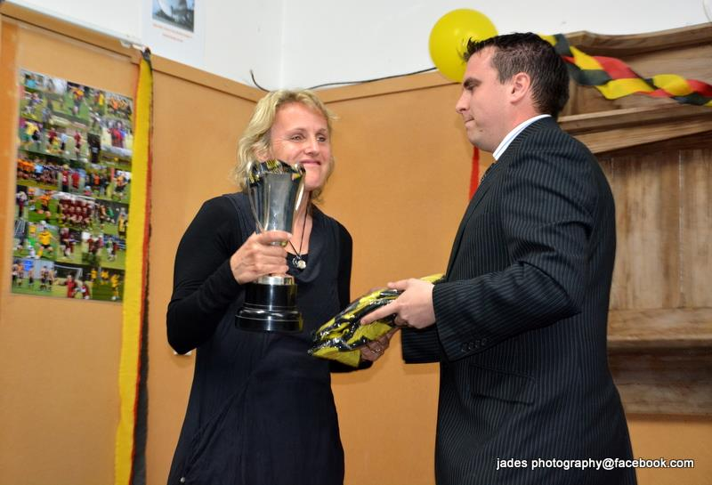

**Areas for future Work**

Increase our financial sustainability through ensuring reliable funding streams is maintained.

Increase policy development and formalising arrangements through good documentation and record keeping.

Developing MOU with our support organisations and fellow clubs.

**Conclusion**

The Greytown Football Club has going through a significant change for the 2013 year. We have had a change of long serving personnel and new committee members bought in. This year we acknowledged Paul Southey as our first life member for his dedication and services to building the GFC as it is today.

The club has faced some external challenges, which have assisted in building some sound process around the management of media, and the discipline of our members.

However despite these initial challenges the Club has continued to grow and build upon the great foundations set in previous years. We have seen the development of younger members and a team now playing competitively in the Wellington Capital 3 League. Success at the local level is continuing and the club culture of a family oriented and all inclusive club is maintained.

2013 has seen us build upon our resources and facilities to help ensure the sustainability of the club. The floodlight project was completed, a freezer was purchased and a better system adopted for managing the bar was implemented. Relationships with external stakeholders have continued with many projects coming to fruition which will ensure top notch facilities are maintained at the club.

Many teams and clubs continue to comment on the atmosphere and culture within our club and how they enjoy playing games at   
Greytown.

Lastly we would like to acknowledge and thank our sponsors, support  
partners, players and funders for what has been a successful year. Without this continued support the GFC wouldn’t have been able to achieve these results in 2013.

**Chris James**

**Club President**

**Greytown football club would like to thank and acknowledge our major sponsors:**

 



&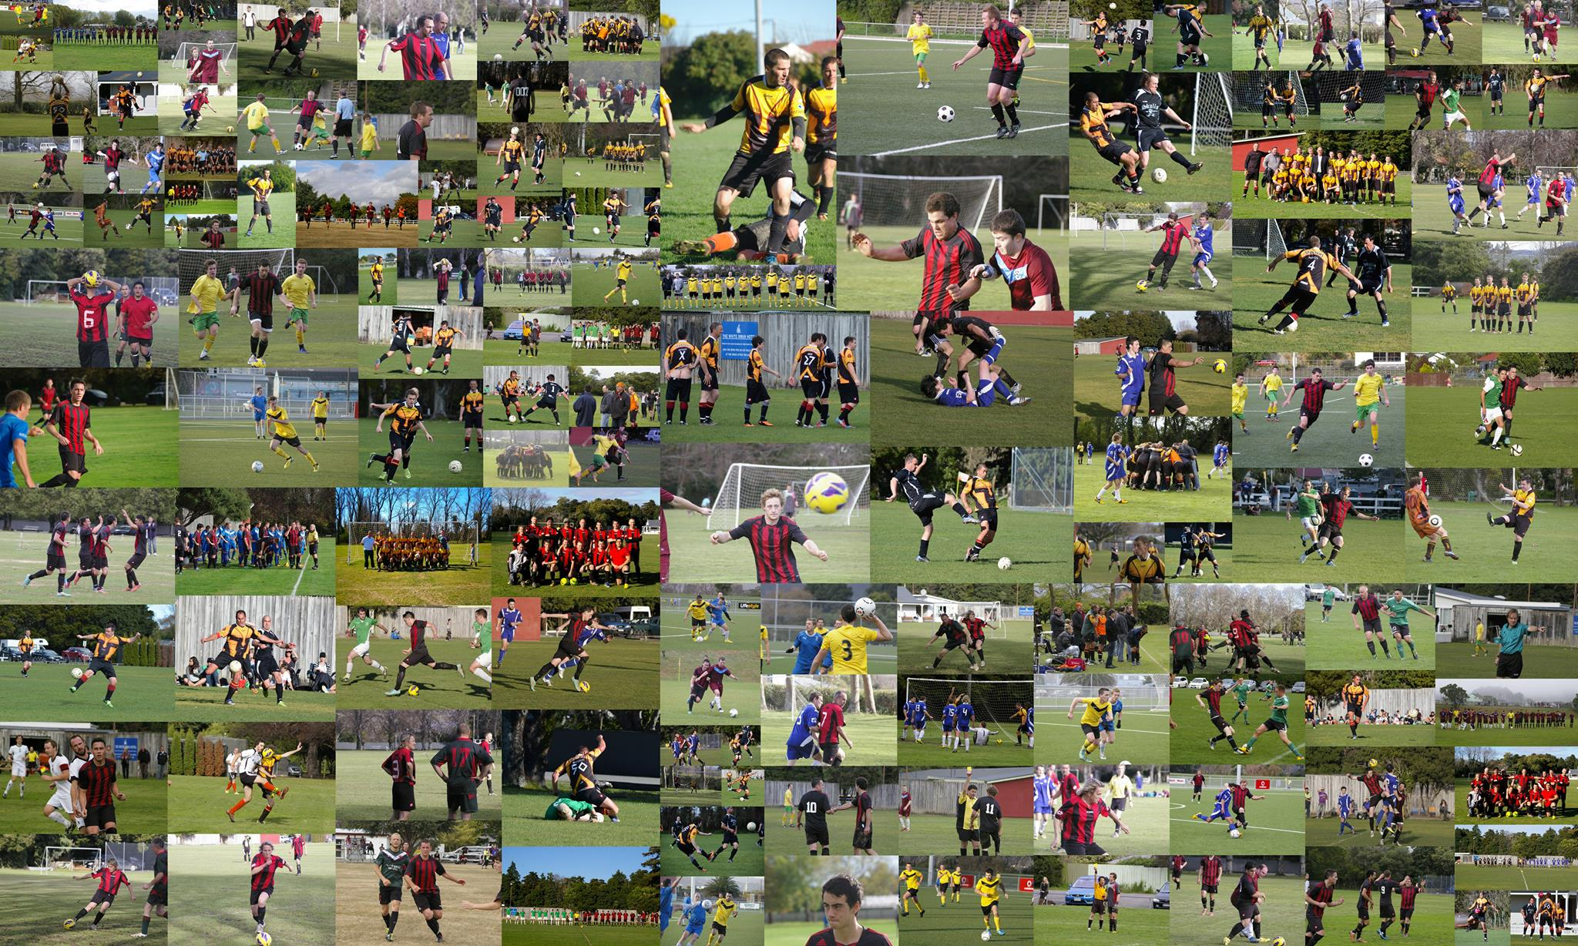

Southey Building Construction